**PIZZA SALES MYSQL QUERIES**

**A. KPI’s**

**1. Total Revenue:**

SELECT SUM(total_price) AS Total_Revenue FROM pizza_detail;

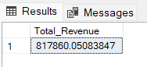

**2. Average Order Value**

SELECT (SUM(total_price) / COUNT(DISTINCT order_id)) AS Avg_order_Value FROM pizza_detail;

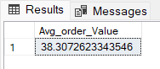

**3. Total Pizzas Sold**

SELECT SUM(quantity) AS Total_pizza_sold FROM pizza_detail;

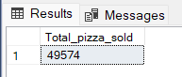

**4. Total Orders**

SELECT COUNT(DISTINCT order_id) AS Total_Orders FROM pizza_detail;

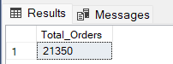

**5. Average Pizzas Per Order**

SELECT CAST(CAST(SUM(quantity) AS DECIMAL(10,2)) /

CAST(COUNT(DISTINCT order_id) AS DECIMAL(10,2)) AS DECIMAL(10,2))

AS Avg_Pizzas_per_order

FROM pizza_detail;

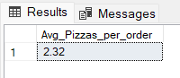

**6. Changing Date Column Datatype**

ALTER TABLE pizza_detail

CHANGE COLUMN order_date order_date DATE;

**B. Daily Trend for Total Orders**

SELECT DAYNAME(order_date) as Weekly_day, COUNT(DISTINCT order_id) as TOTAL_ORDERS from pizza_detail

GROUP BY DAYNAME(order_date);

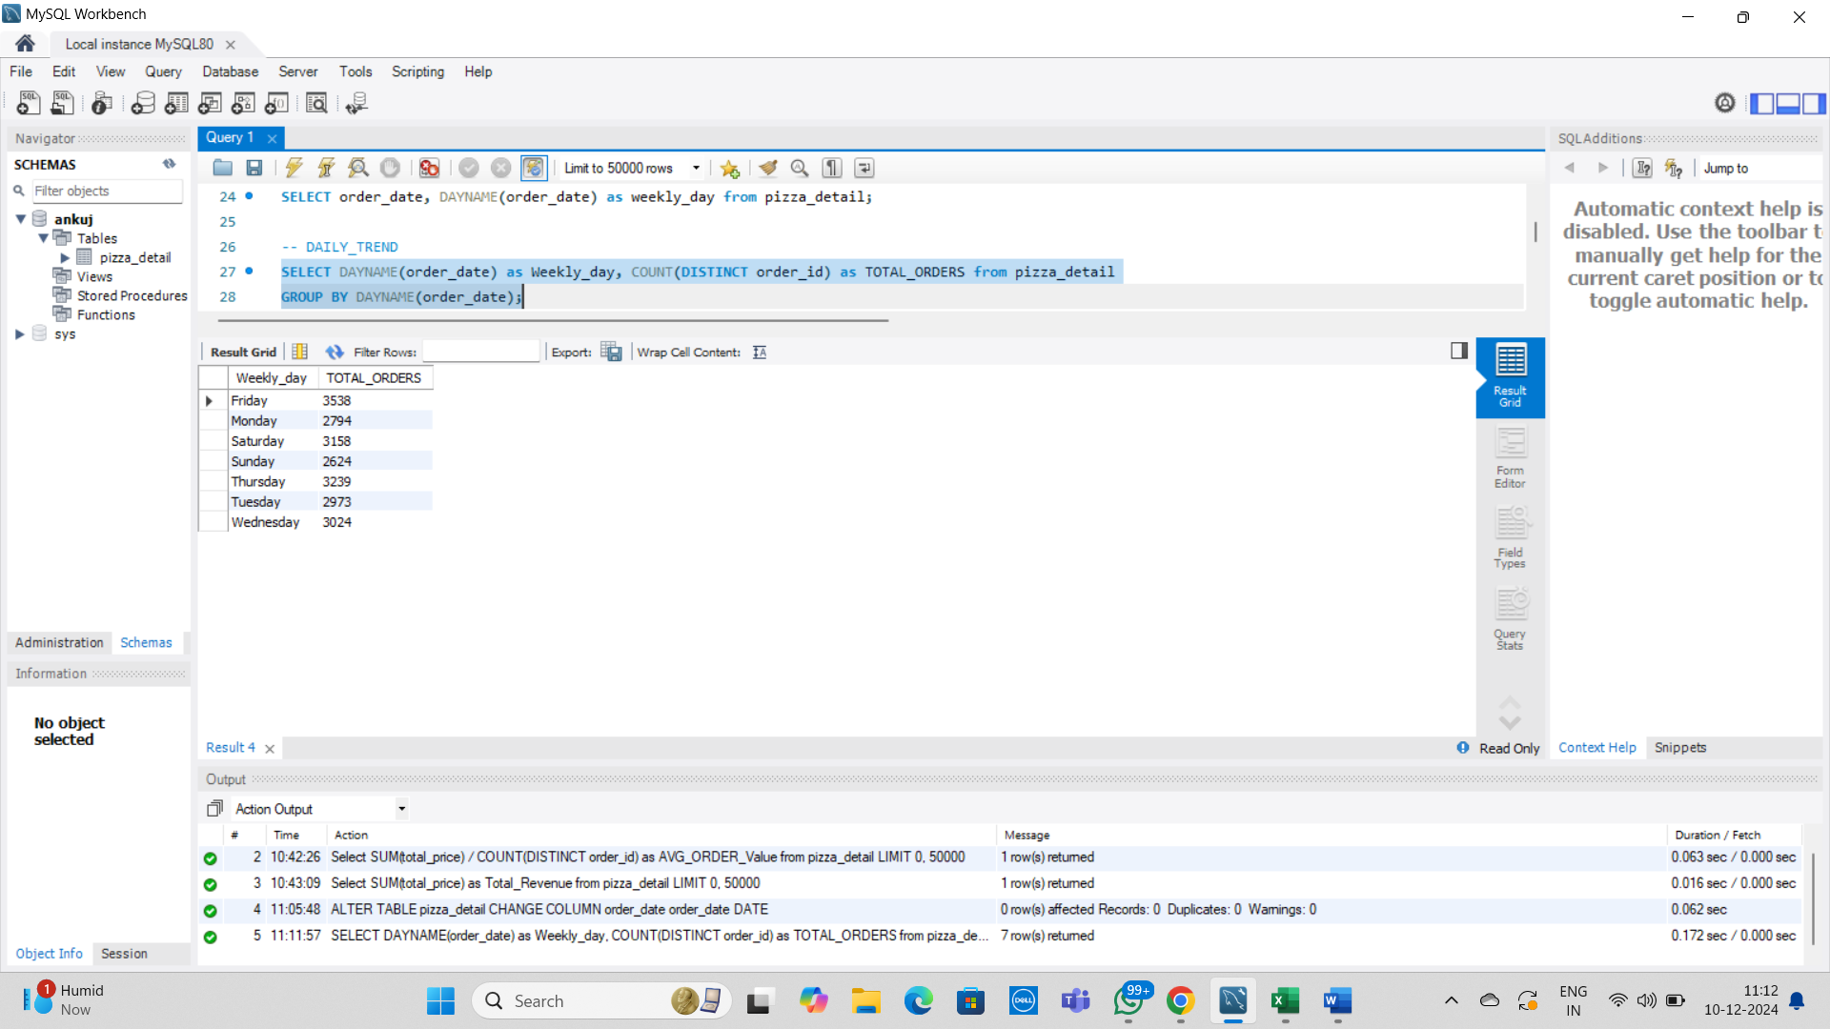

**C. Hourly Trend for Orders**

SELECT HOUR(order_time) as Hourly_trend, COUNT(DISTINCT order_id) as TOTAL_ORDERS from pizza_detail

GROUP BY HOUR(order_time);

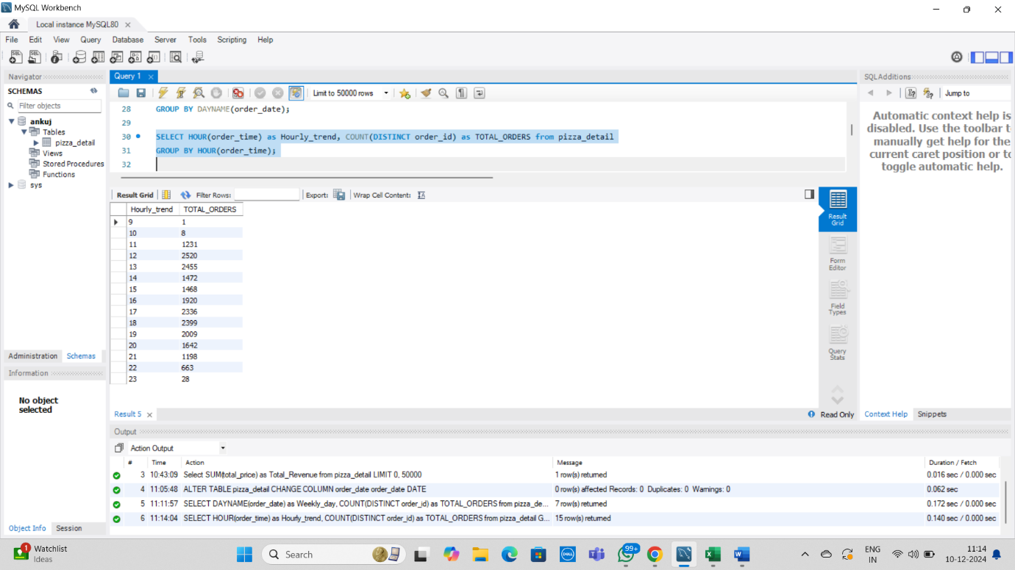

**D. Percentage of Sales by Pizza Category**

Select pizza_category, SUM(total_price)*100/ (Select SUM(total_price) from pizza_detail) as Percentage_total_sales

from pizza_detail

GROUP BY pizza_category;

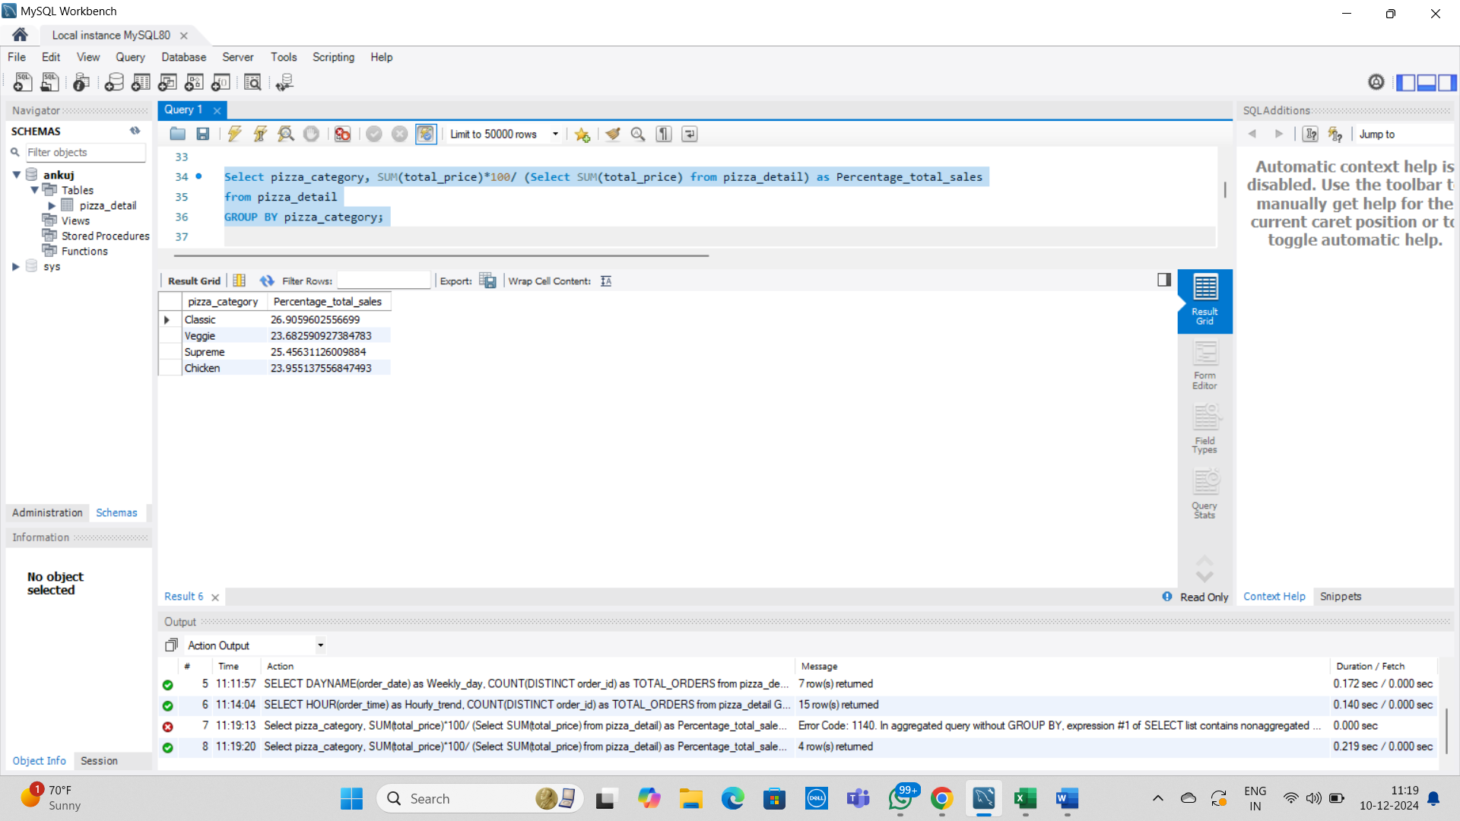

**E. Percentage of Sales by Pizza Size**

Select pizza_size, CAST(SUM(total_price) as DECIMAL(20,4)) as total_sales,CAST(SUM(total_price)*100/ (Select SUM(total_price) from pizza_detail) as DECIMAL(10,2)) as Percentage_total_sales

from pizza_detail

GROUP BY pizza_size

order by pizza_size, Percentage_total_sales;

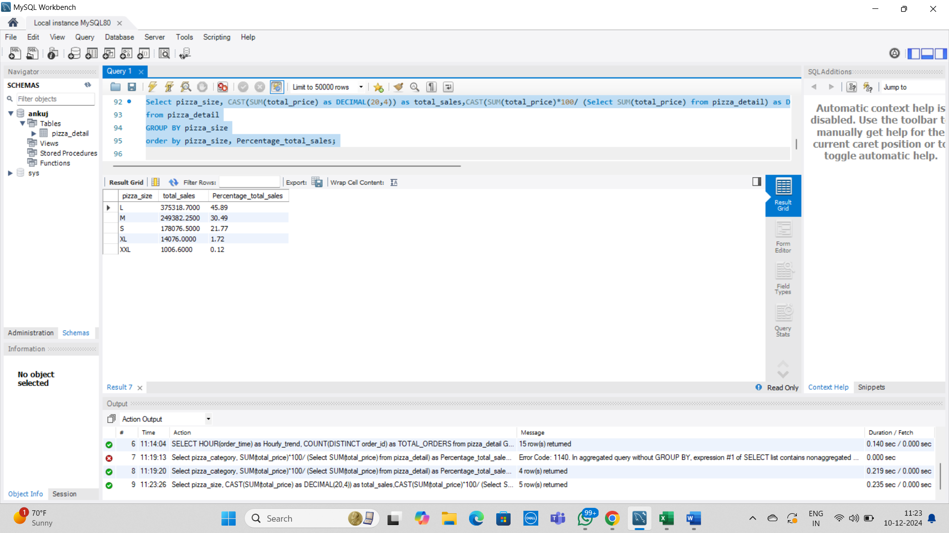

**F. Total Pizzas Sold by Pizza Category**

Select pizza_category, SUM(quantity) as total_units from pizza_detail

GROUP BY pizza_category;

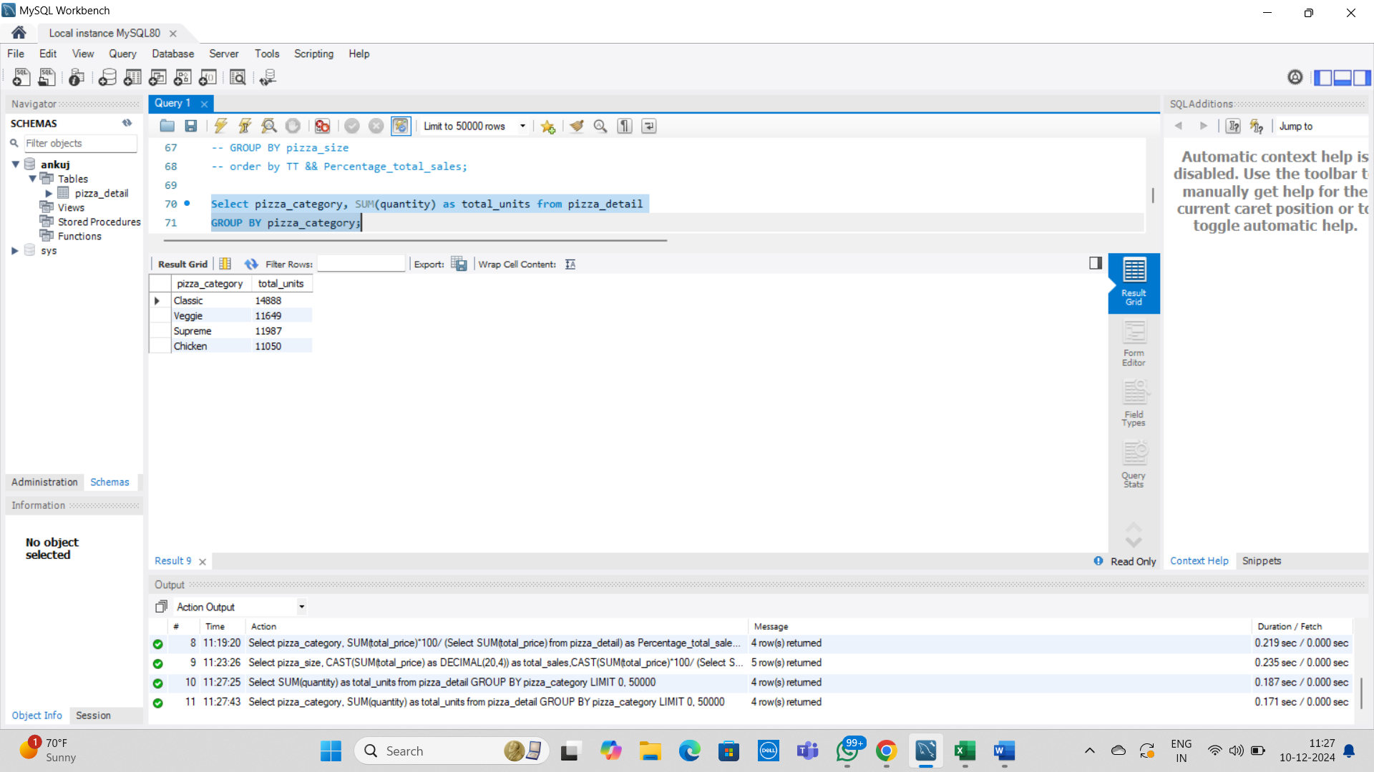

**G. Top 5 Best Sellers by Total Pizzas Sold**

Select pizza_name, SUM(quantity) as total_units from pizza_detail

GROUP BY(pizza_name)

ORDER BY(total_units) DESC

limit 5;

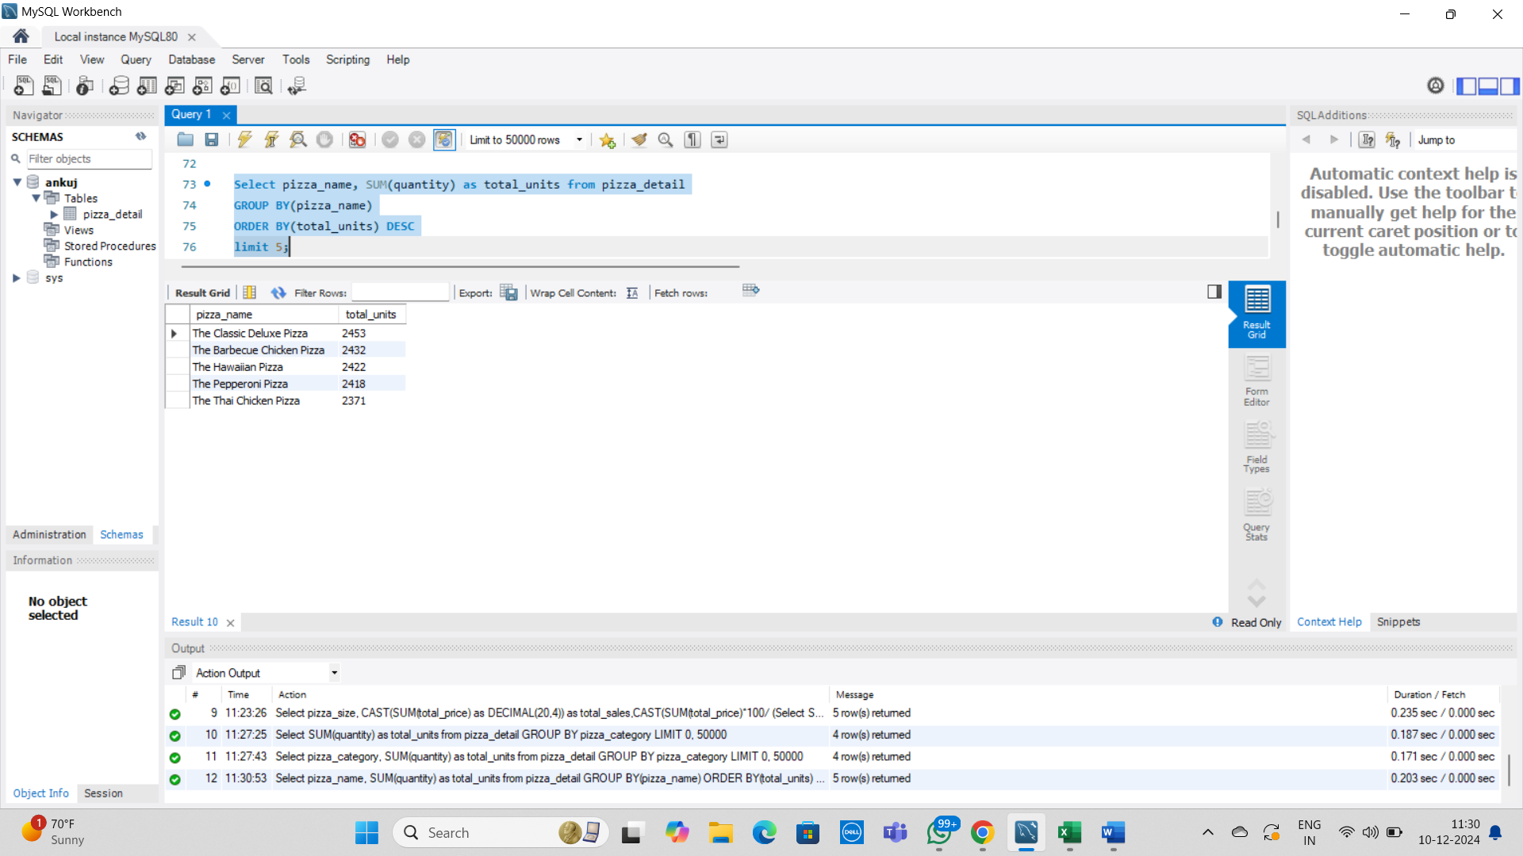

**H. Bottom 5 Best Sellers by Total Pizzas Sold**

Select pizza_name, SUM(quantity) as total_units from pizza_detail

GROUP BY(pizza_name)

ORDER BY(total_units)

limit 5;

